**MACHINE LOGISTIC PROJECT**

In this project, I have used SVM Regression Machine Learning model for the iris dataset from Kaggle website

**PROBLEM STATEMENT:**

The Iris flower data set or Fisher's Iris data set is a multivariate data set introduced by the British statistician and biologist Ronald Fisher in his 1936 paper The use of multiple measurements in taxonomic problems as an example of linear discriminant analysis. It is sometimes called Anderson's Iris data set because Edgar Anderson collected the data to quantify the morphologic variation of Iris flowers of three related species. Two of the three species were collected in the Gaspé Peninsula "all from the same pasture, and picked on the same day and measured at the same time by the same person with the same apparatus".

**ML METHODOLOGY:**

SVM a support vector machine(SVM)is machine learning algorithm that analyzes data for classification and regression analysis….SVMs are used in text categorization ,image classification ,handwriting recognition and in the science.

**DATASET DESCRIPTION:**

Some relevant columns in the dataset

* Sepal length(cm)
* Sepal width(cm)
* petal length(cm)
* petal width(cm)
* Flower_type

**PRE_PROCESSING:**

Pre_processing refers to the transformations applied to our data before feeding it to the algorithm.

import numpy as np

from sklearn.svm import LinearSVC

from sklearn import datasets

from sklearn.preprocessing import StandardScaler

model=LinearSVC()

model.fit(X,Y)

X=[[0,0],[1,1]]

Y=[0,1]

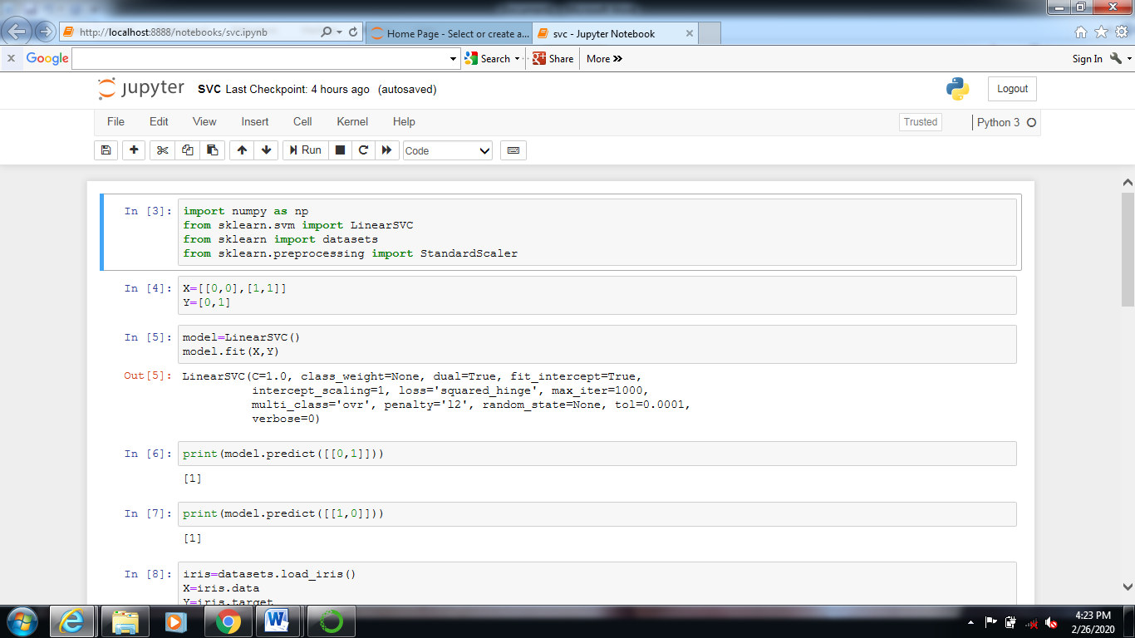

**print(model.predict([[0,1]]))**

**print(model.predict([[1,0]]))**

**iris=datasets.load_iris()**

**X=iris.data**

**Y=iris.target**

**print(iris.data)**

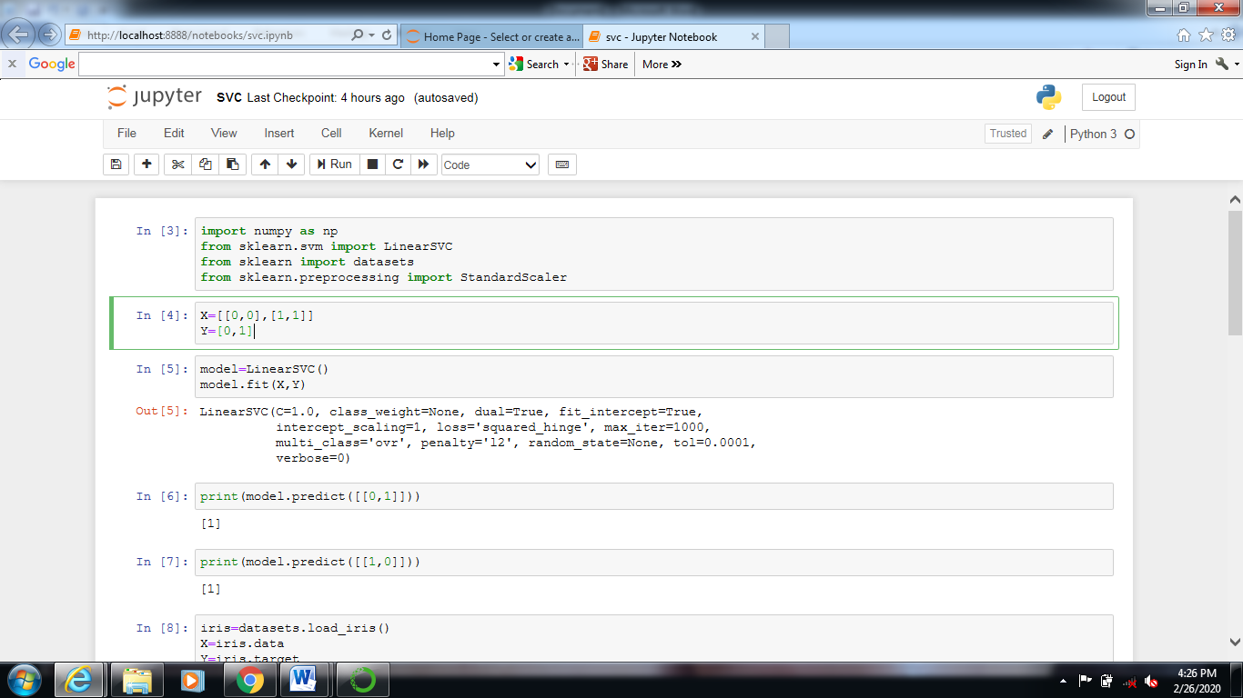

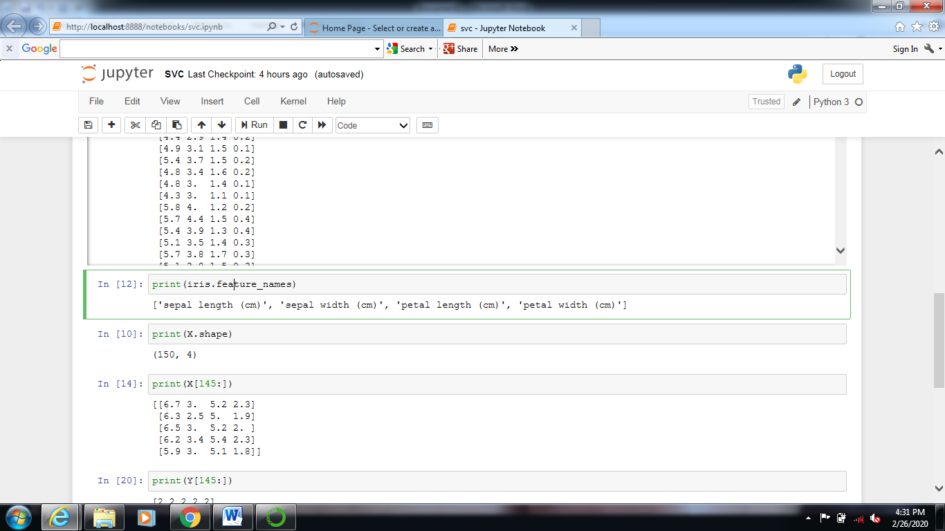

**print(iris.feature_names)**

**print(X.shape)**

**print(X[145:])**

**print(Y[145:])**

**scaler=StandardScaler()**

**X_std=scaler.fit_transform(X)**

**model=LinearSVC(C=1.0)**

**model.fit(X_std,Y)**

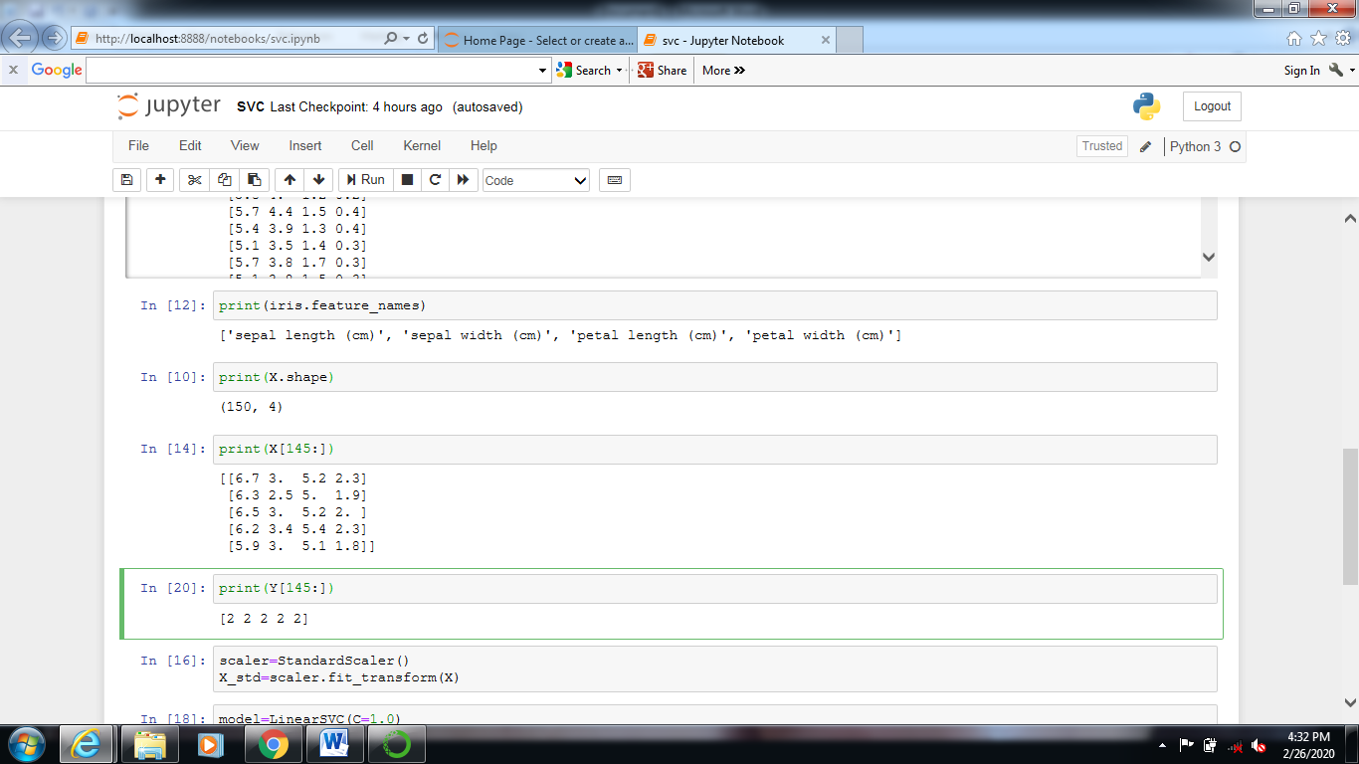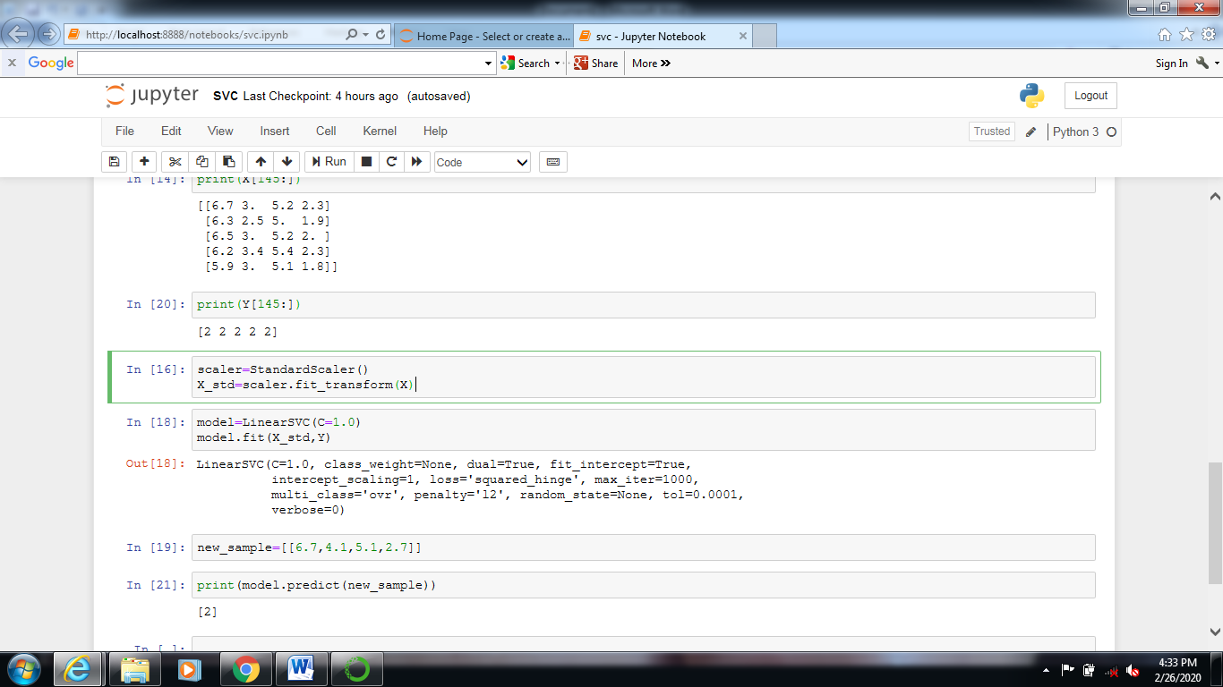

**CONCLUSION:**

Model weights of datasets are calculated by using SVM Regression and calculate the training and testing dataset.